(Approx. 1437 words)

BitTorrent
By Dick Maybach, Member, Brookdale Computer Users’ Group, NJ
January 2015 issue, BUG Bytes
www.bcug.com
n2nd (at) att.net

BitTorrent, http://www.bittorrent.org/, is a peer-to-peer file sharing protocol for transferring files over the Internet. The conventional way of transferring data is for one site to act as a file server, which stores the files and transmits them on demand. If many people want the file, this requires a high bandwidth connection to avoid long download times. In the BitTorrent scheme, the central site is called an indexer, and it functions as a file director rather than a file server. (Actually, the situation is somewhat more complex. There are also sites called trackers that work with and assist indexers. Most people blur this distinction and use the term tracker for both indexers and trackers, and I'll do the same for the rest of this article.) When a user requests a file from a tracker, he or she receives a Torrent Descriptor File that contains a list of sites, called seeders, that currently are making the file available for transfer. On the user's computer a program called a BitTorrent Client uses information in the descriptor file to request pieces of the desired file from the seeders. Since each of the many seeders supply only a few pieces of the file, their upload volumes and rates are low. The descriptor file also contains a checksum for each piece of the file and the client uses these to ensure that the downloaded file has no errors. BitTorrent allows individuals to share files with many others without requiring the use of expensive facilities. By spreading the distribution task among many servers, BitTorrent reduces traffic congestion on the Internet thus speeds up data rates for everyone, including those that aren't using peer-to-peer sharing. Peer-to-peer file sharing is so widely used that by some estimates it accounts for half or more of all Internet traffic. As of January 2012, there were 150 million active BitTorrent Users.

Some people use peer-to-peer file sharing to distribute illegal material. Don't do this. Media corporations have convinced some courts to make examples of individuals who illegally obtain copyrighted work, and the resulting fines have been truly punitive. The same corporations actively monitor Internet peer-to-peer sharing activity. The risks far outweighs the rewards of watching a movie or listing to music that you don't think is worth paying for. In addition, the sites that distribute such material are dishonest and won't hesitate to infect your computer with malware.
I use BitTorrent to download Linux distributions, which are often occupy several Gbytes. When a new distribution is first released, the official sites are often overloaded, and this of course is when I'm most interested in obtaining it. Many sites anticipate this, and make it convenient to use BitTorrent as an alternate to a direct download.

Security

The BitTorrent client software resides on your PC, and you should take the same precautions installing it as with any other program. In addition to the usual worries about malware, you depend on this program to upload only the files you designate and only at those times you allow. Windows users should obtain it from a reliable source and check it for malware before using it. Linux and OS X users have fewer concerns since they use the client Transmission, which is in the official repositories. Regardless of your confidence in the package, do not install it on a corporate machine, as most businesses prohibit file sharing. The Windows client μTorrent, available at www.utorrent.com/downloads/win?us is a safe choice. Unfortunately, it changes your default search engine to Ask.com and installs the Ask.com toolbar in your browser. You will want to undo this, as a search using Ask.com produces mostly marketing sites having little or no relation to your search. An alternative Windows client is available at http://www.bittorrent.com/, but the free version displays advertising; a deluxe version without advertising is available for $20. Before using BitTorrent, install and configure a software firewall, such as ZoneAlarm, www.zonealarm.com/, for Windows. This will limit the access to your PC and will help ensure that only what you intend is uploaded.
Be careful choosing a tracker, as many specialize in downloading illegal material. You could consider Jamendo (www.jamendo.com/en/welcome),which distributes Creative Commons licensed albums and Linux Tracker (linuxtracker.org/), which distributes Linux distributions. An Internet search will show many other trackers, but again be careful. The BitTorrent Descriptor File that the tracker sends you contains checksums for each piece you obtain from individual seeders, which guarantees the integrity of the pieces. Thus you aren't dependent on the nature of the seeders.
Limit which files and directories you share by setting the preferences in your BitTorrent client. In my case, I allow sharing only from my Downloads directory and only those files I've obtained using BitTorrent, which are the defaults in the Linux client. Some clients by default allow sharing everything on your PC, and you must change this before beginning a download. After the download is complete, scan it with an anti-virus program as you would with any software, regardless of the means by which you obtain it. Many Linux software providers provide MD5 checksums that you can use to be sure every bit in the file is correct. Unfortunately, this is rare in the Windows world.

Process

To obtain a file, go to the tracker's Website and select the desired BitTorrent descriptor file, which will have the extension .torrent, and will have a size of 30 Kbytes or so. How you get this to the BitTorrent client program on your PC depends on how you have set things up. You may accomplish it just by double-clicking on the file name on the Website; in the worst case, you will download the file to your PC and open it with the client. The client should start and within a few seconds you should see both the file you want coming in and some of the files you've decided to share going out. It's considered good manners to send at least as much data as you receive, in fact some trackers insist on it to the extent that they will limit your downloads if your upload volume isn't sufficient. Because the upload rate is much less than that of the download, you will have to let the client run long after the download is complete to satisfy this.

The following example uses Linux to download a file using BitTorrent. The process is the same for OS X and Windows, although the screens will be different. The first step is to go to a tracker Website and click on the file you want, which will produce the window below, giving you the usual choice of opening the file with Transmission (the BitTorrent client for both Linux and OS X) or downloading it to your PC. Note that this is a small BitTorrent descriptor file, not the large one you want to download. Usually, you'll choose the first option.

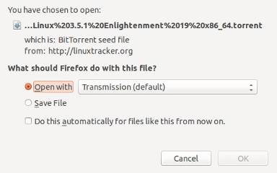

Assuming you choose the Open with option, the next screen will show the file to be downloaded and give you an opportunity to change the destination folder from the default (in this case Downloads). If you had aborted an earlier download of the same file, the Have amount would not be 0 %, and you would have only to download the pieces you didn't already have.

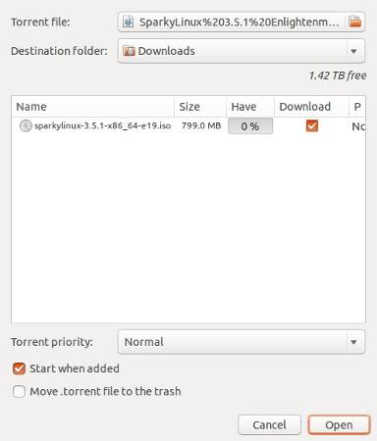

The next screen shows BitTorrent downloading the sparkylinux file. You can see that I've previously obtained eight other files using BitTorrent, that ubuntu-mate is being uploaded, and that although two peers are interested in wheezy-raspbian the upload rate is zero. At the time of the screen-shot, nobody connected to this tracker wanted the other files.

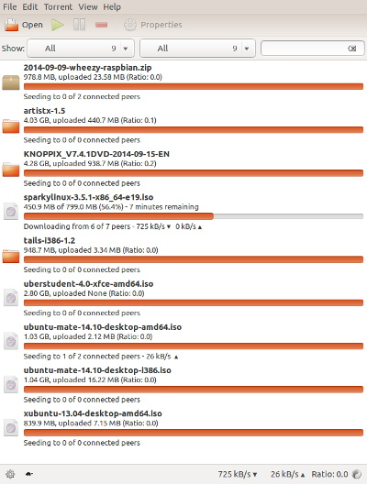

Right-clicking on the sparky-linux item on the download screen after the download was complete and selecting properties shows the next screen. We can see that the 799 Mbyte file was downloaded as 1524 pieces of 512 Kbytes each and there were no errors.

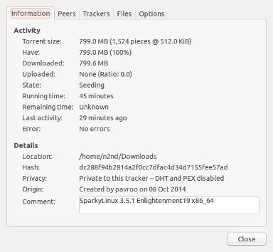

Should you use BitTorrent? I've found that it takes a fraction of the time to download large files as direct transfer, especially if the file server is busy, which seems to be the usual case for the files I want. Also, some files are available only by peer-to-peer transfer. You do have to be careful to obtain a BitTorrent client you can trust, to set up your firewall properly, to use reliable trackers, and to check the download for malware. These precautions are similar to what you would do with any new file regardless of how you obtained it. Ultimately, the choice is yours; if BitTorrent makes you uneasy, don't use it.

